**LAB 4**

**Terraform Variables**

**STEP 1: Create a new Directory.**



**STEP 2: Create terraform configuration file (main.tf)**

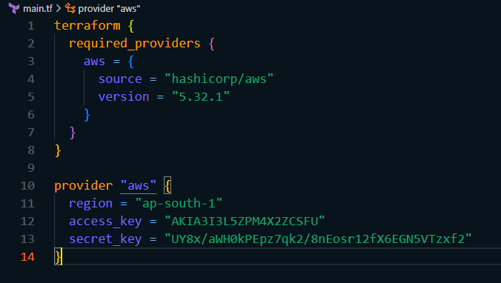

**STEP 3: Create a new file named variables.tf and define variables for region, ami, and instance_type.**

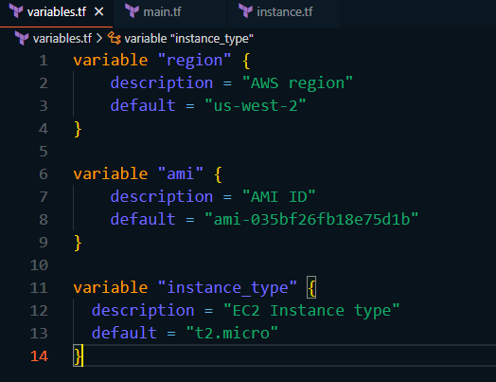

**STEP 4: Modify main.tf to use the variables.**

**main.tf**

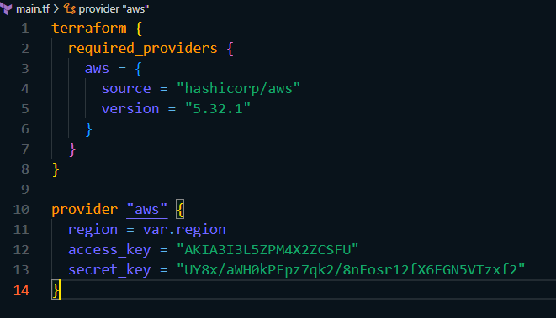

**instance.tf**

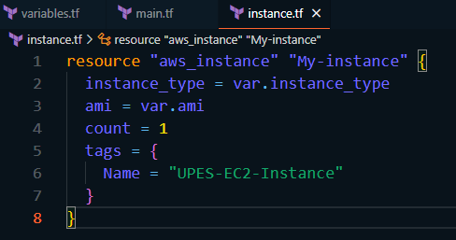

**STEP 5: Initialize and Apply the changes made.**

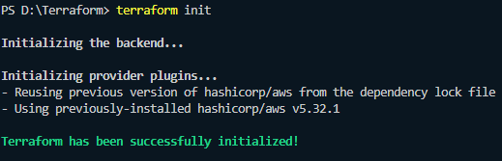



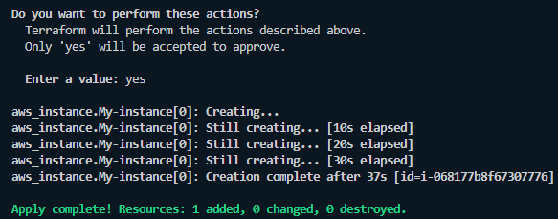

**If you check on AWS you can see the that the instance has been launched.**

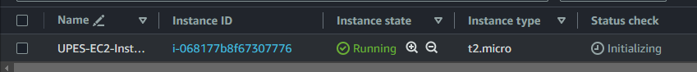

**STEP 6: After testing we clean up the resources.**

